**Introduction/Business Problem**

**To identify the best places to setup a restaurant in the city of Toronto, Canada.**

**The analysis uses the location data from Foursquare to identify the various popular venues in and around various neighborhoods in Toronto. This kind of analysis will help us to identify what all neighborhoods are lacking a good restaurant and the kind of cuisine in Toronto.**

**Data Acquisition and Cleaning**

**Here I use the postal codes, geographic coordinates mapping table from the Wikipedia page:** <https://en.wikipedia.org/wiki/List_of_postal_codes_of_Canada:_M>

**The above data is cleaned to remove those entries wherein the Boroughs are missing and formatted to a Pandas dataframe.**

**Foursquare API is used to explore various Boroughs/Neighborhoods and to get a list of various venues in those Neighborhoods. Further, the venues are sorted according to the popularity of the respective venues.**

**For example, from the following table (contains data of few Neighborhoods) its clear that there are playgrounds and parks in those Neighborhoods, but lacking good Italian/Chinese restaurants. A good Italian/Chinese restaurants can attract young crowd.**

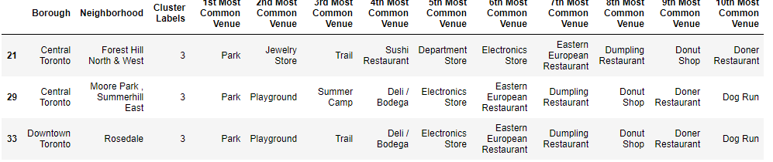

**Methodology and Discussions**

**Predictive Modeling using K-means clustering algorithm(Unsupervised)**

**Since the output here is unlabeled or unknown, we use unsupervised learning to find patterns from the data.**

**Above data is then fed to k-means clustering algorithm to cluster these Neighborhoods based on various parameters available.**

**Below we can see the result of K-means embossed on a map of Toronto:**

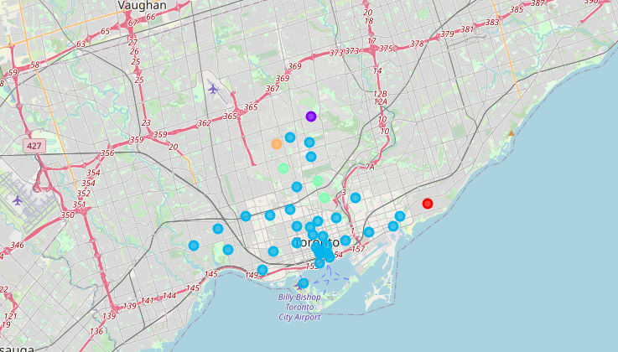

**As seen above the neighborhoods were clustered into 5 clusters (colored with different colors) and the detail of the clusters can be seen in the below shown tables:**

**Cluster 0:**

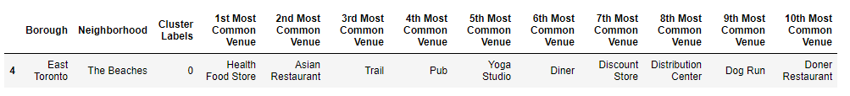

**Cluster 1:**

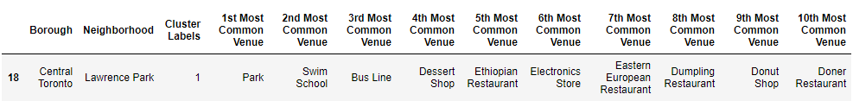

**Cluster 2:**

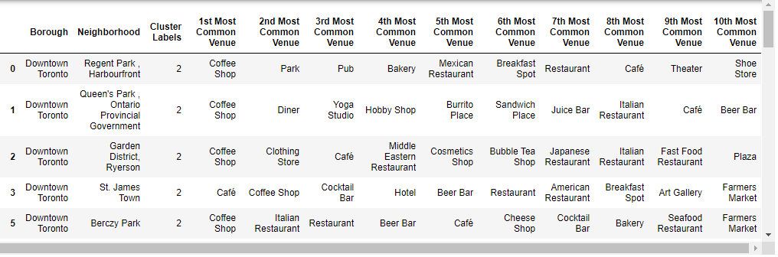

**Cluster 3:**

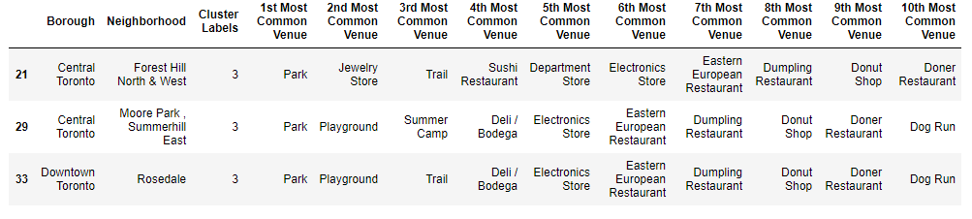

**Cluster 4:**

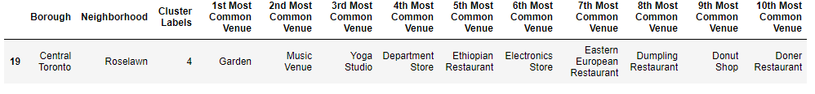

**Conclusions:**

**From the study above, I have found that cluster 3 has parks and playgrounds and few European restaurants. However, there are no good Italian/Chinese restaurants, pubs etc. Therefore, an Italian/Chinese restaurant or juice bars/pubs/bars in these neighborhoods should attract crowd especially the young crowd.**